Nepal Thalassaemia Society update by Wendy Pinker

Dear all 12 May 2015

I am writing to give an update on the condition of our families in Nepal. As I’m sure many will now be aware there has been another enormous 7.3 earthquake this morning in the Everest region less than 60 miles from Kathmandu.

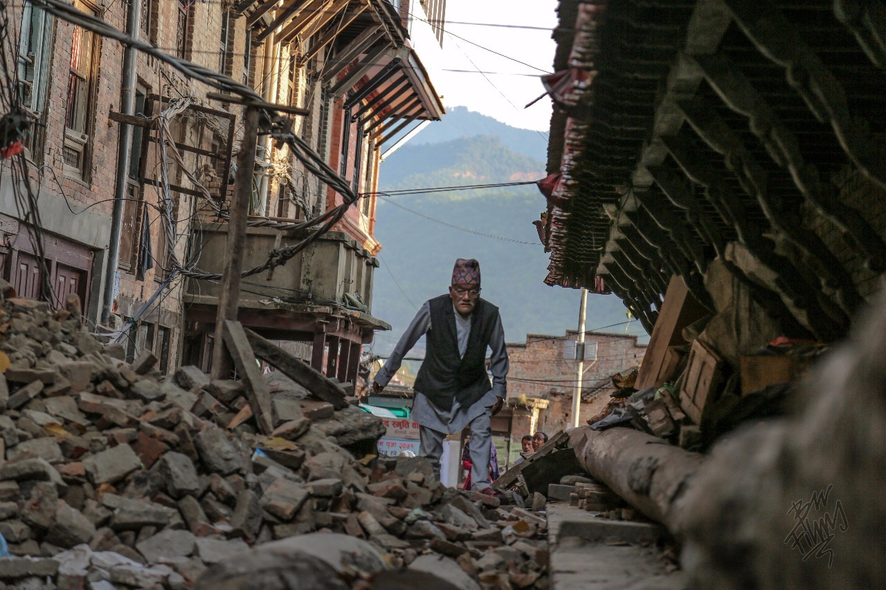

Nepal suffered much devastation less than 2 weeks ago and with todays events I’m sure the suffering of the people will only continue to grow … people are now living in constant fear and many have not slept inside since the day of the first quake.

Many deaths are already being reported and scenes of devastation in the capital, Kathmandu are live on the Internet.

Within just 10 minutes of the quake today I had a phone call from my sons father, Rishi to say he was ok but please could I check the internet as all the power was down in Pokhara (West of Kathmandu) and nobody knew what was going on… He said that the earth shook so hard everyone was swaying on the ground.

Appeal Update

Shortly after the first quake myself and Elaine Miller of the UK Thalassaemia Society launched an emergency appeal for help. The response has been staggering with

£9000.00

Being donated to date. There are also many fund raising events being planned by both people I know and many who I have never met. It’s truly humbling.

The events of the last 2 weeks have touched hearts all over the world and there are no words to express my sincere gratitude and thanks to all those who have helped and continue to us in our mission to support our devastated families. Please accept my apologies for not writing personally to everyone … it has been a struggle to keep up with so much kindness and so much generosity. I am deeply grateful to all.

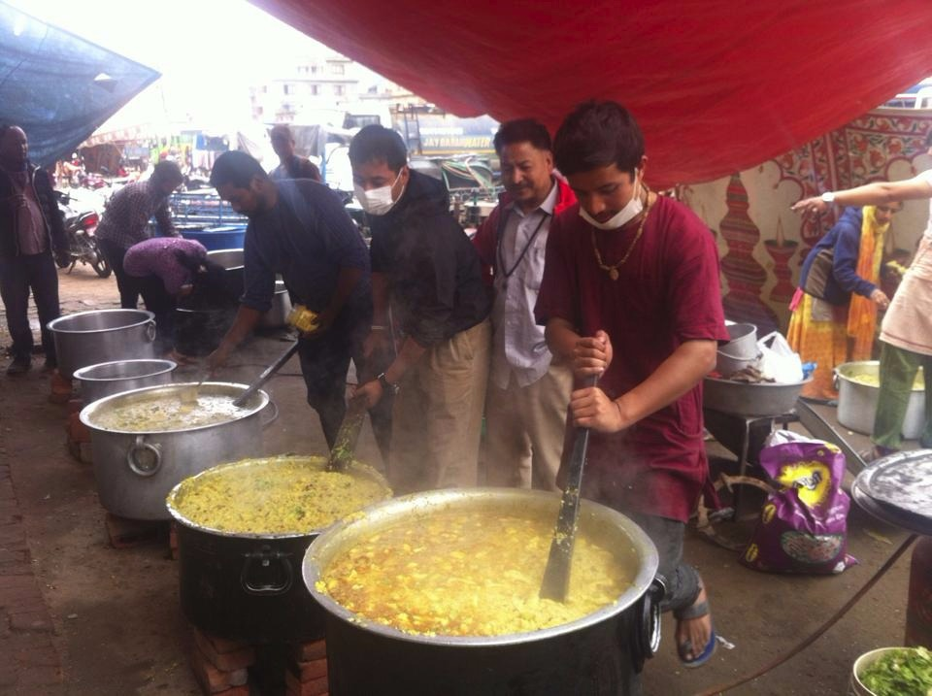

I have been in as much communication as possible with our clinic President Durga Pathak in Kathmandu and we now have information that a large number of our families have been affected including 3 who lave lost everything … their homes, their belongings and their life stock which is also their livelihood.

Listed below is what even the smallest donation will help us with :

Temporary Accommodation funds : £10 per week per family
Mattresses, pillows, blankets £60 for a whole family
Clothing £50 per family
Kitchen items £60 for a complete set
Supplies of rice and dhal (lentils) £12 per 30kg sack
New life stock : buffalo, goats and chickens £ 5 for a live chicken
Essential Farming tools £40 for a basic set
Live saving BLOOD AND MEDICINE £ 4 per packet of blood

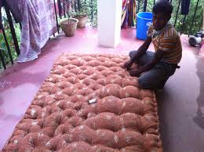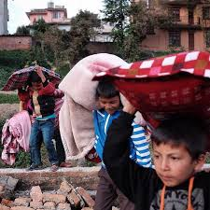

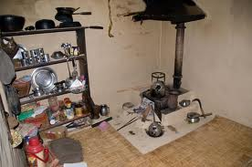

The needs at this time are enormous and the help that you have given us will go a long way to getting many families back on their feet.

Thank you for your donation and your support
From all at Nepal Thalassaemia Society.

With love Wendy Pinker

EVERY SINGLE PENNY that is raised is sent directly to the Nepal Thalassaemia Society in Nepal …. Not one penny will be used for administration or any other costs …..

Thank you

Wendy Pinker
07836 572062

To make a donation please see the details below :

Bank Account
Nepal Thalassaemia Society
Account HSBC 71463209
Sort Code 40 47 34
Cheques
Payable to : Nepal Thalassaemia Society
Send to : Wendy Pinker, 13 Phoenix Way, Portishead, Bristol, BS20 7FG

Email Wendy : pinkyland_2000@yahoo.co.uk

