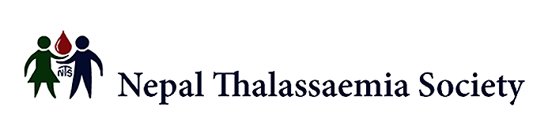
Charity Gift Aid Declaration
Boost your donation by 25p of Gift Aid for every £1 you donate
Gift Aid is reclaimed by the charity from the tax you pay for the current tax year. Your address is needed to identify you as a current UK taxpayer.

In order to Gift Aid your donation you must tick the box below:

I want to Gift Aid my donation of £_ and any donations I make in the future or have made in the past 4 years to:

the Nepal Thalassaemia Society (Registered Charity No. 1167957)

I am a UK taxpayer and understand that if I pay less Income Tax and/or Capital Gains Tax than the amount of Gift Aid claimed on all my donations in that tax year it is my responsibility to pay any difference.

My Details Title Name

Address

Postcode Tel.

Email

Signature Date

Please notify the charity if you:
- want to cancel this declaration
- change your name or home address
- no longer pay sufficient tax on your income and/or capital gains

If you pay Income Tax at the higher or additional rate and want to receive the additional tax relief due to you, you must include all your Gift Aid donations on your Self-Assessment tax return or ask HM Revenue and Customs to adjust your tax code.
Thank you for your valued support.

Please return this form to

Nepal Thalassaemia Society,
c/o Elaine Miller, Dove Cottage, 244-246 Manchester Road, Sheffield, S36 9NR

